**Library Management System**

**Index:**

1. Test Framework Overview

2. Test Execution Results

3. Requirements Gaps

4. Bugs

**1. Test Framework Overview**:

Please find the test framework project details:

**Project Folder Name**: LibraryManagementSystem

**ReadMe File**: Attached as part of the zip file for instructions

The Test framework is built to test Library Management system, which covers below scenarios like add, edit, delete and read books (CRUD operations):

CREATE Operations:

1. A valid user login in for adding a new book and checking if the book is added to the list

2. Valid User adding a new book with blank details and checking if appropriate error messages are displayed

3. Valid User adding a new book with blank title and checking if appropriate error messages are displayed

4. Valid User adding a new book with blank Author and checking if appropriate error messages are displayed

5. Valid User adding a new book with blank Genre and checking if appropriate error messages are displayed

6. Valid User adding a new book with blank ISBN and checking if appropriate error messages are displayed

8. Valid User adding a new book with Invalid Date (text) and checking if appropriate error messages are displayed

9. Valid User adding a new book with blank Price and checking if appropriate error messages are displayed

10. Valid User edits a book with valid data and checking if the changes are reflected

11. Valid User edits a book with blank title and check if the appropriate error messages are displayed

12. Valid user login deleting a book and check if book is not displayed post deletion

13. Delete all books (no books available scenario) and Check page info

14. Invalid user should not login to application and should display appropriate error messages

15. Invalid user login with blank details and checking for appropriate error messages

16. When LogOut Button is clicked it should redirect to login page

17. BookListPage and AddBookPage URL validations

18. EditBookPage Title validation

19. Invoking Login Screen from Task Page

Testing Framework Explanation:

**Programming Language**:

Built the framework using Selenium with Java as Programming Language.

**Maven**:

Built the Test framework as Maven project which is used as a build automation tool to manage project dependencies like selenium, testNG, WebDriverManager can be provided using pom.xml by reducing manual configuration.

src/main/java 🡪 to store page objects and abstract classes (AddBookPage, EditBookPage.java)

src/test/java 🡪 to store test cases and base classes (LMSTest.java)

**TestNG**:

Used TestNG as testing framework for organizing, managing and executing automated web tests.

This enables to use features like annotations for test set up, data driven testing and parallel execution. Used TestNG assertions to check if the test result and either fail or pass the test based on the expected results matching with actual result.

**Global Properties File**:

Used properties file to store and drive information in key value pair format e.g. browser name.

**Page Object Design Pattern**:

Used page object design pattern where for each web page of application as separate class, storing all web elements locators and its action methods, with in that class which creates an Object repository to improve code reusability, maintainability and readability by separating the test logic from page specific details. Created different page classes like AddBookPage.java, BookList.java, EditBook.Java etc.

**Page Factory**:

Used Page Factory class which simplifies the process of creating Page Objects with Page Object Design Pattern, this automatically initializes the web elements using “@FindBy” annotation to locate elements on the web page.

**Abstract Class**:

Created an abstract class to store all reusable component which can be inherited and used in page object classes.

**Base Test Class**:

Created a Base Test Class to store all reusable methods which can be inherited and used in Test Class. Like teardown method to close or quit the browser.

**Tests**:

Written tests under src/test/test which inherits reusable methods from BaseTest.java class.

Project Folder Structure:

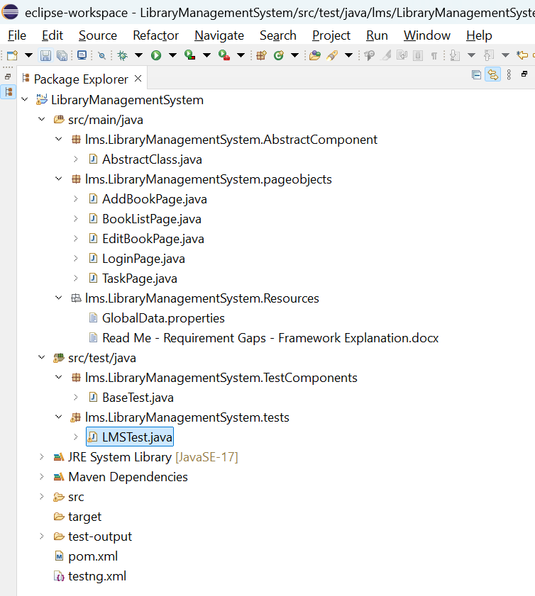

**2. Test Execution Results**:

3 of 19 test cases are failing, logged bugs for the same. Please refer to the Bugs section below (section 4).

Ran tests as ‘Run as TestNG’

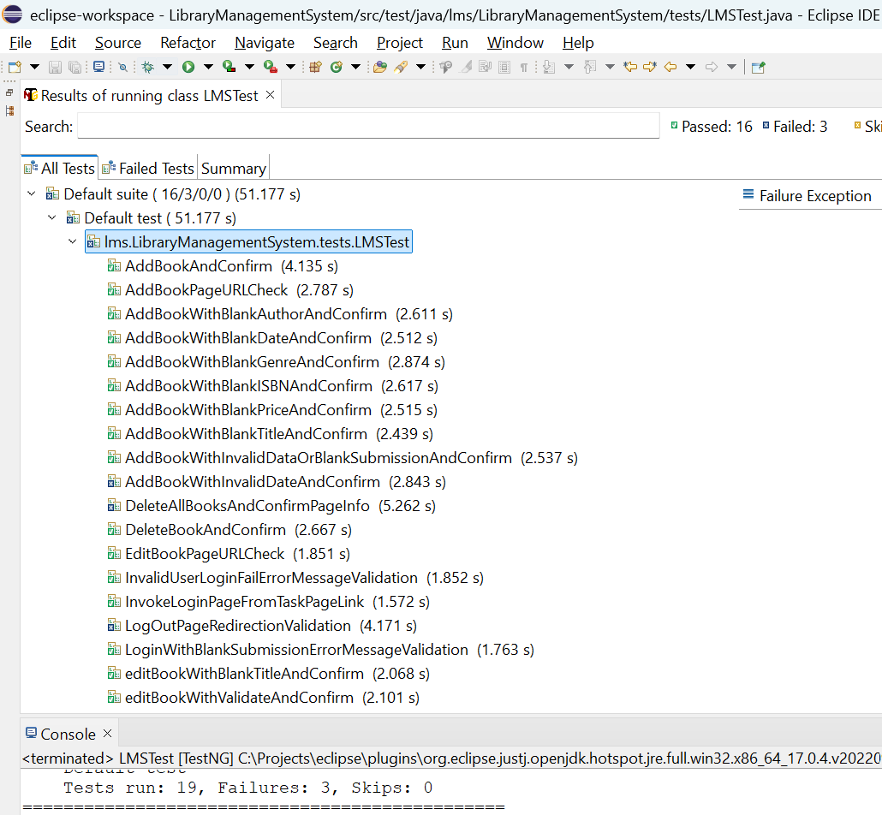

Execution through MVN:

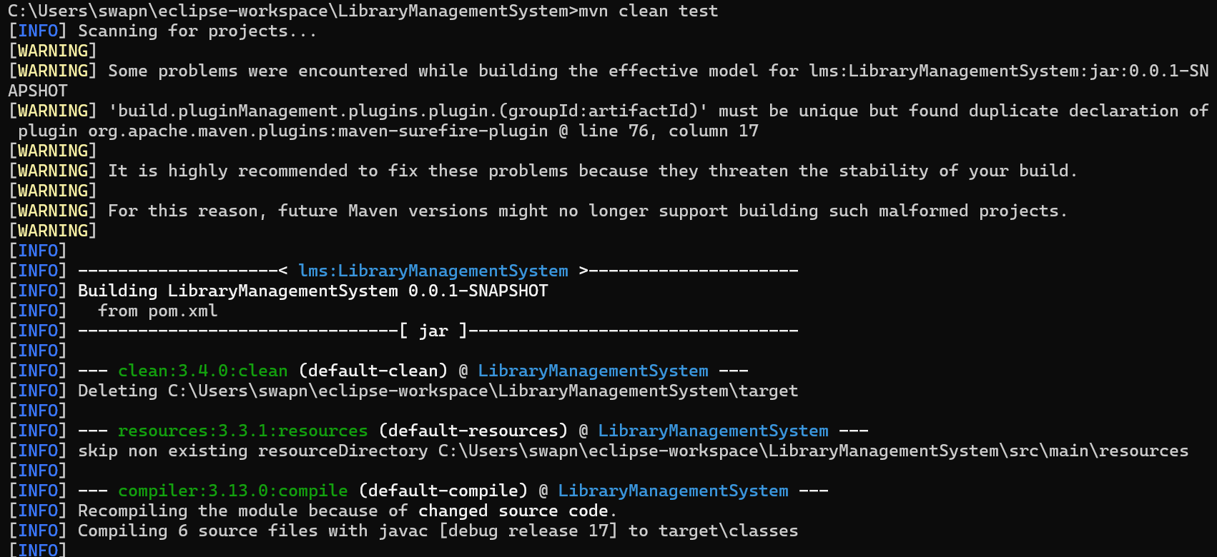

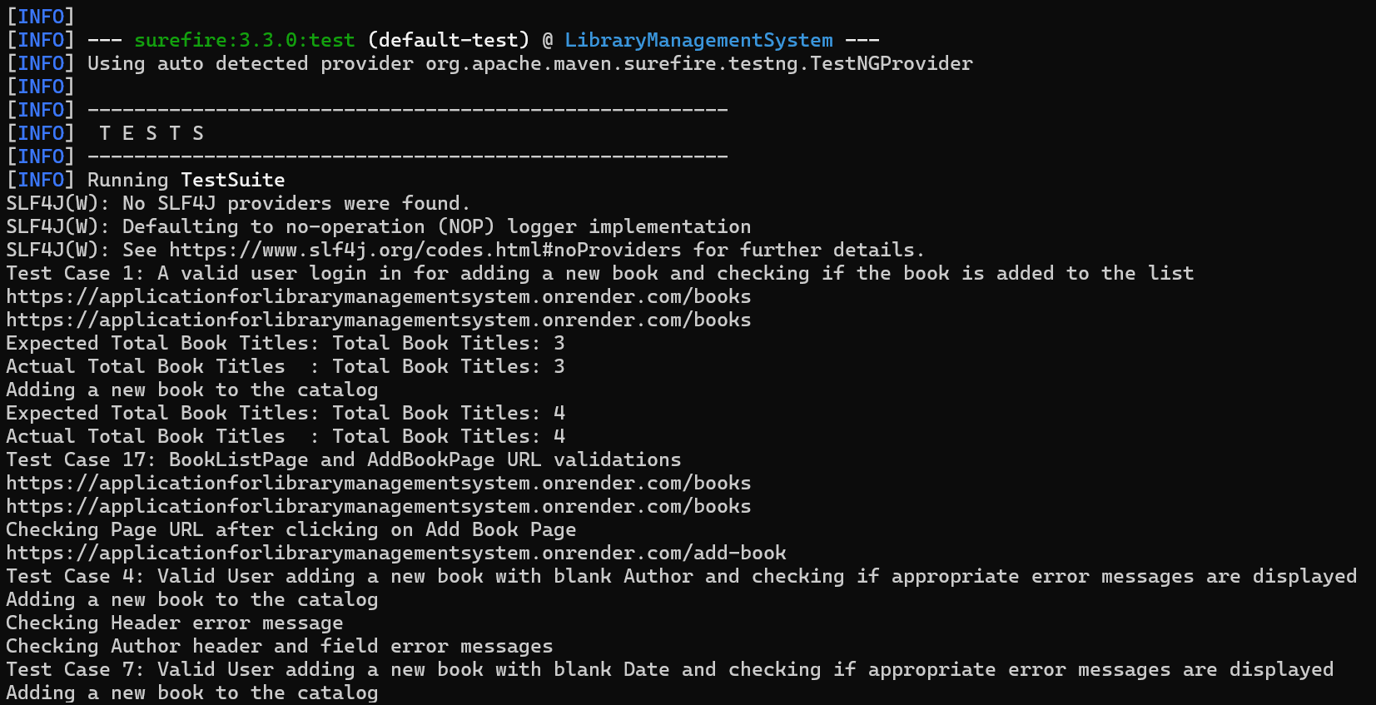 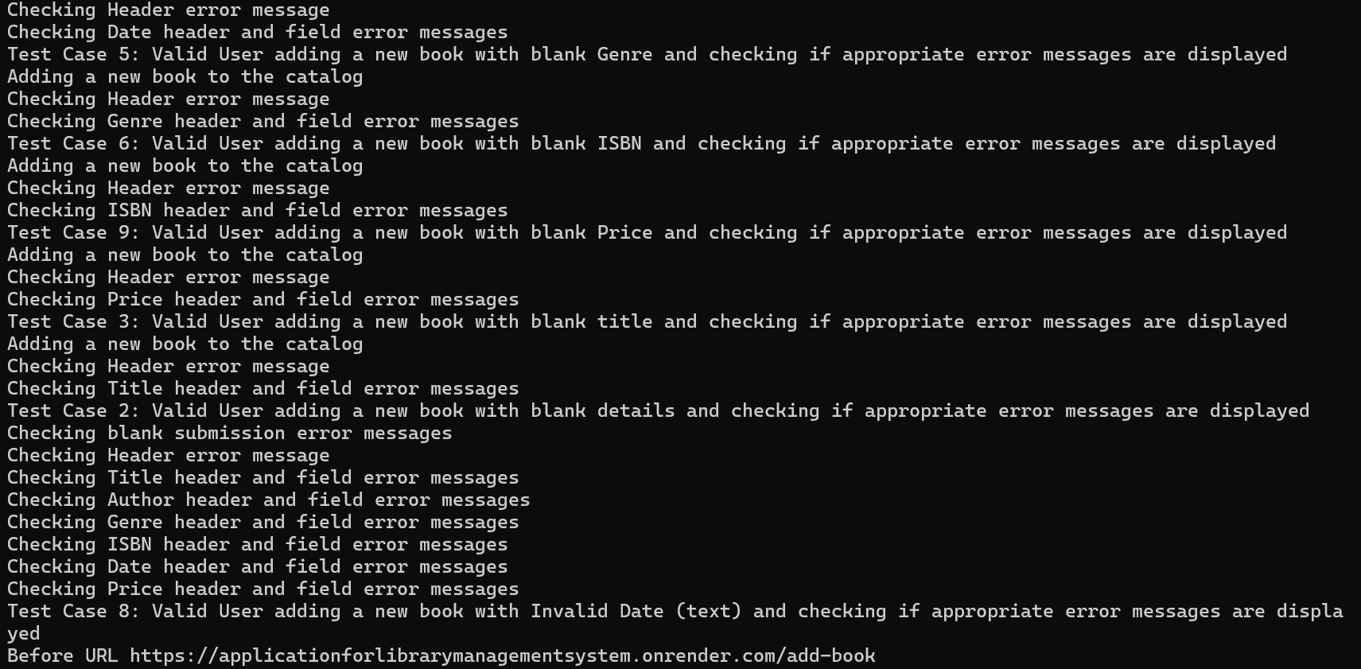 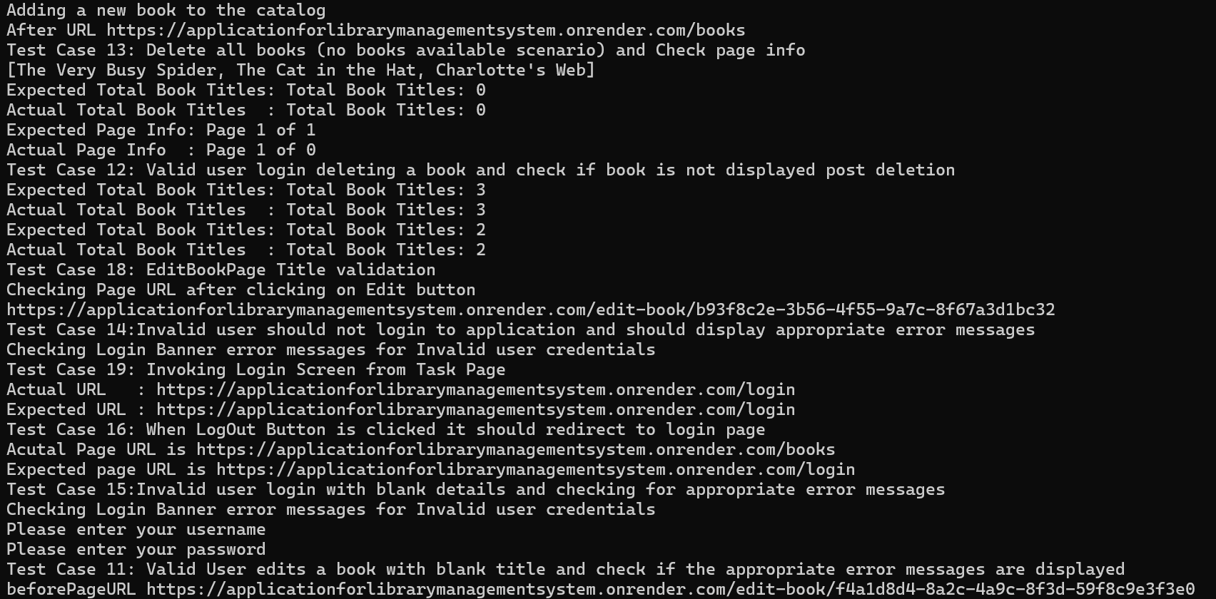 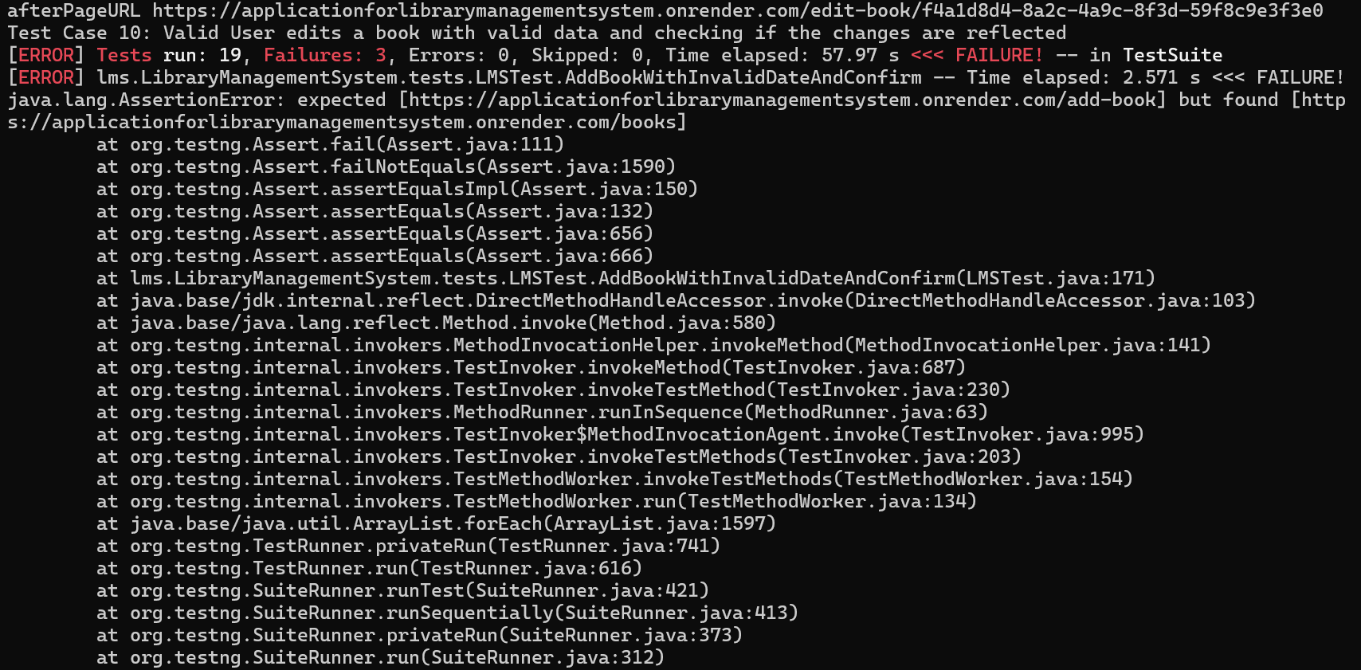 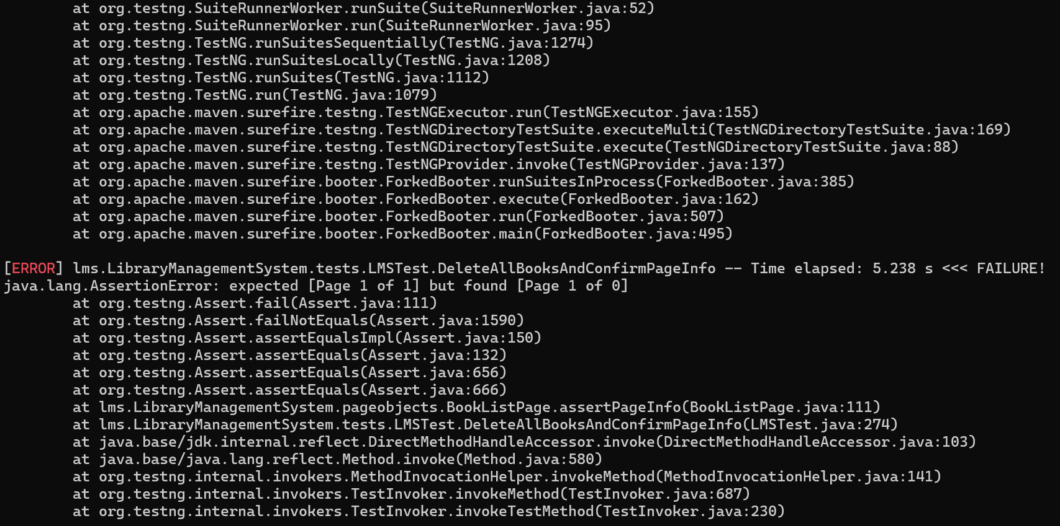 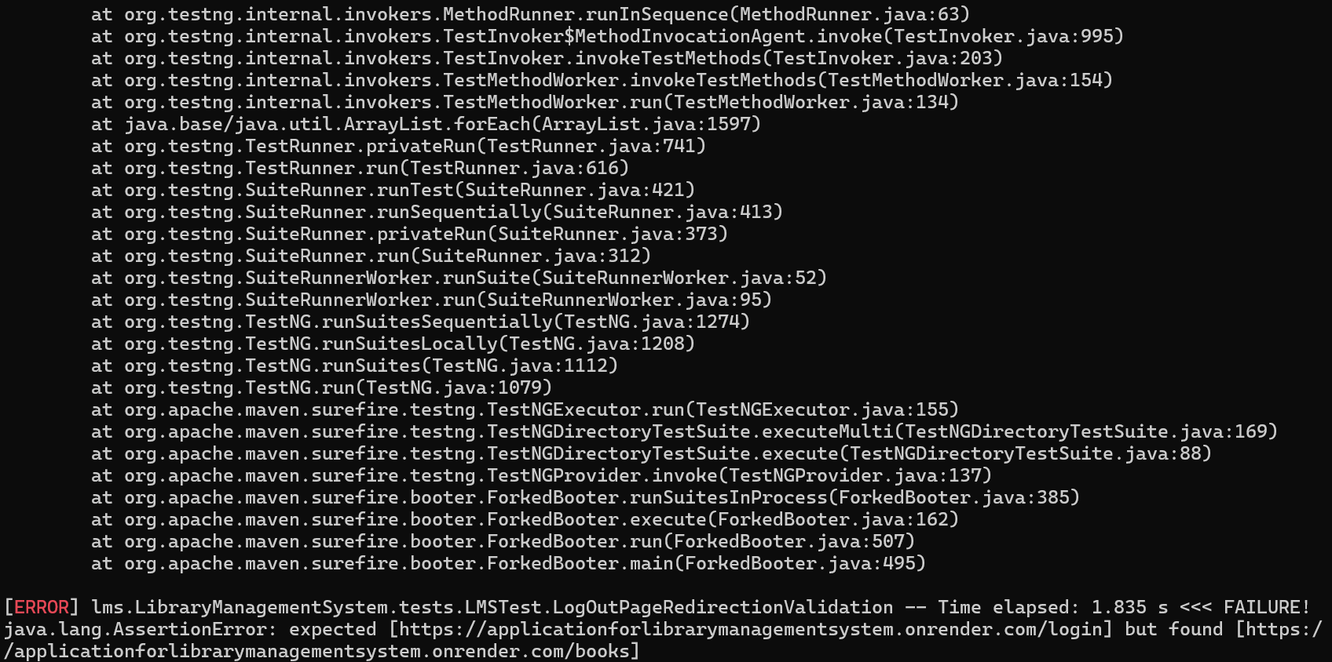 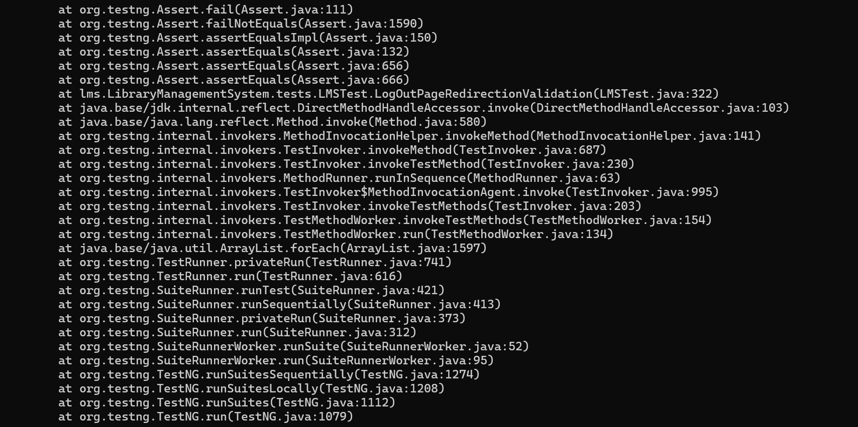 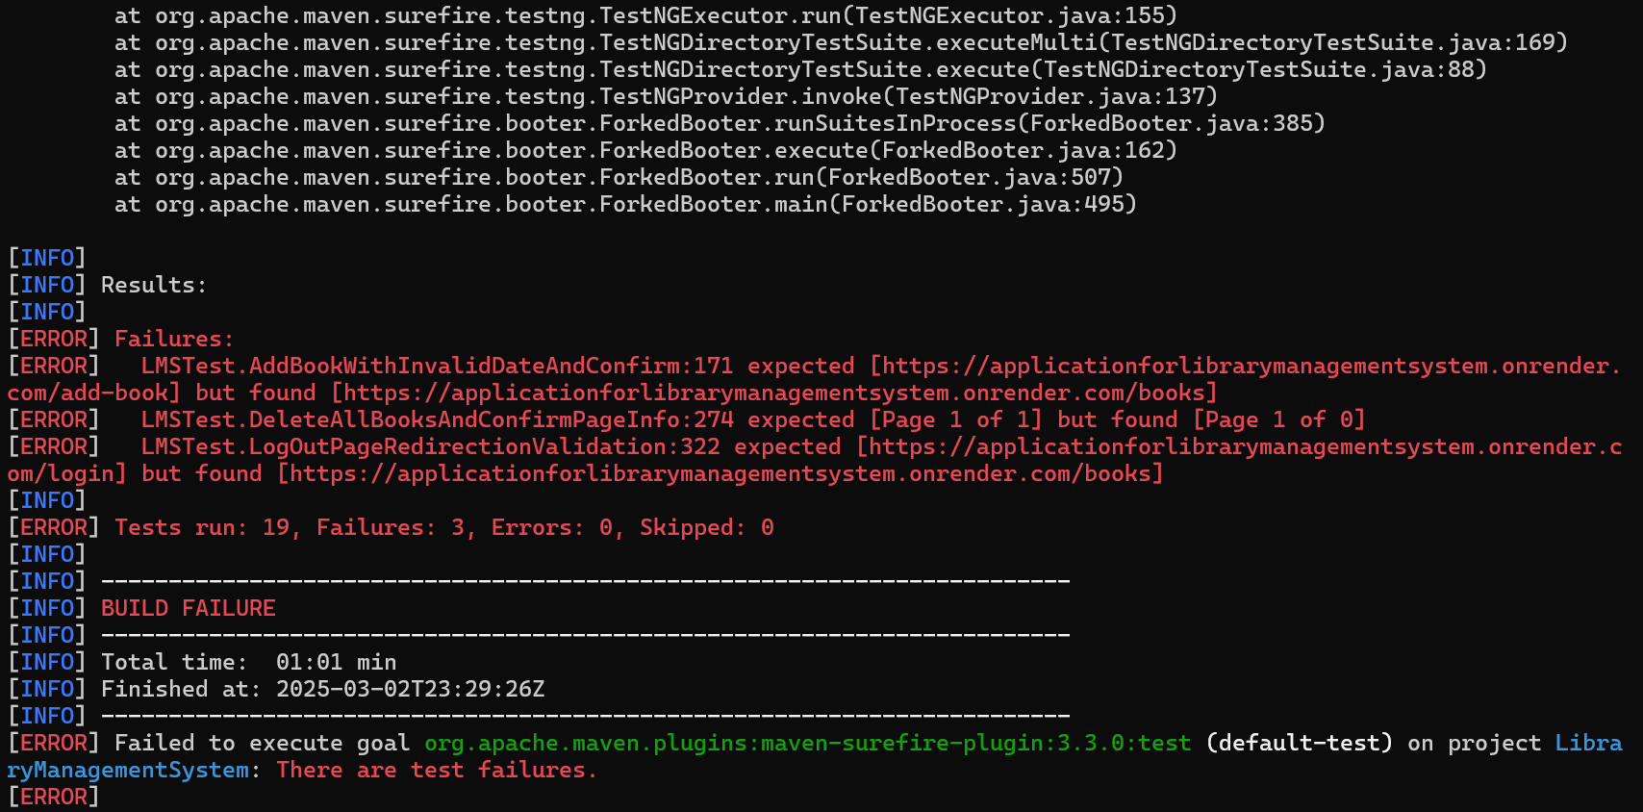

In the above test execution, there are 3 test cases failed and they are valid failures, application bugs and added the bug details in Bugs Section.

Snippets of Error Validations Covered in the Automated Tests:

TC_2 Blank Submission errors TC_3 Title blank Errors

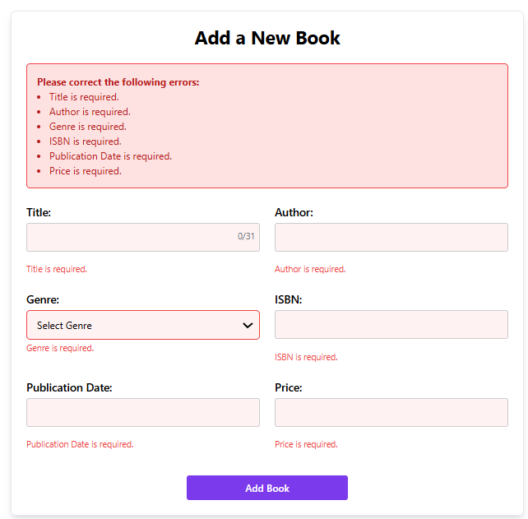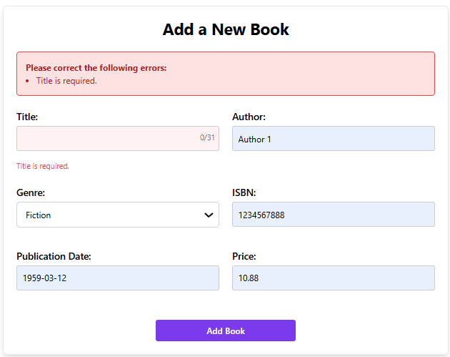

TC_4 Author blank errors TC_5 Genre blank errors

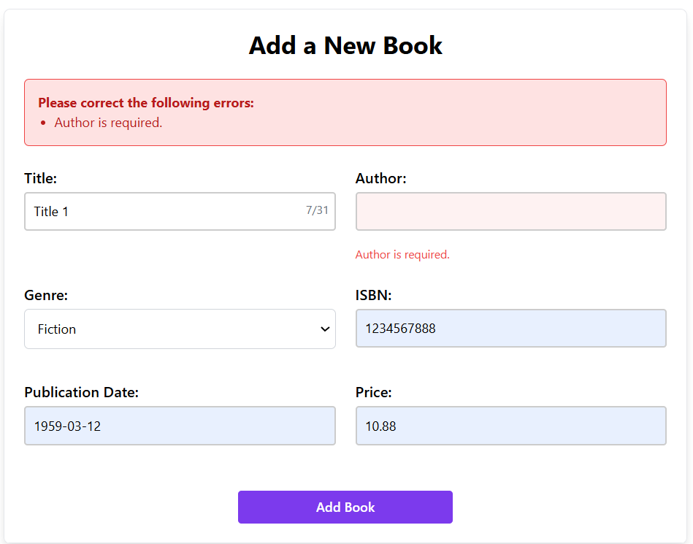 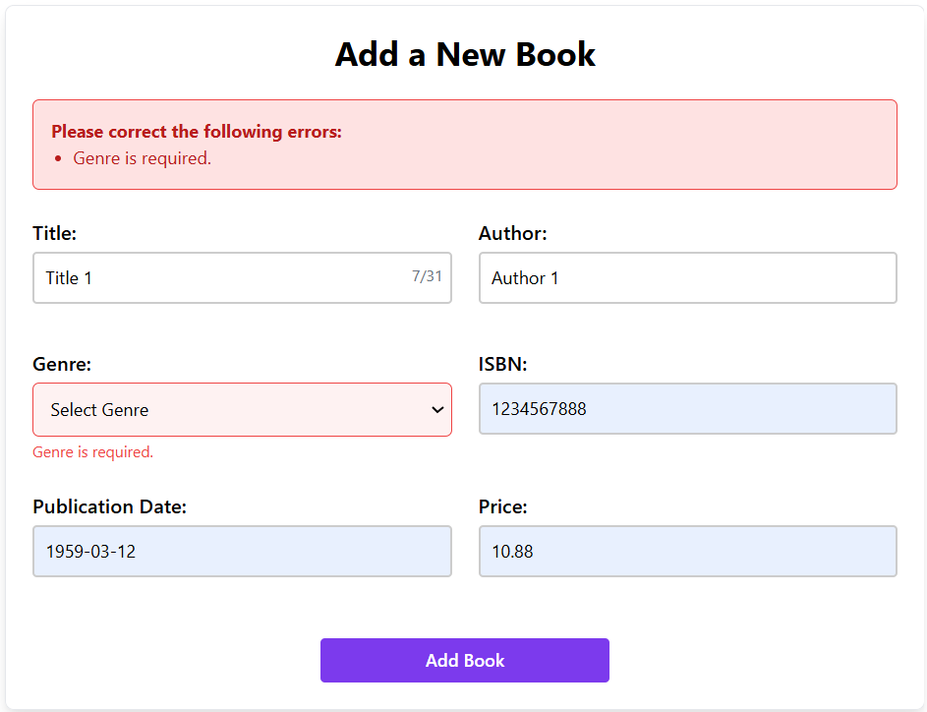

TC_6 ISBN blank errors TC_7 Publication Date blank errors

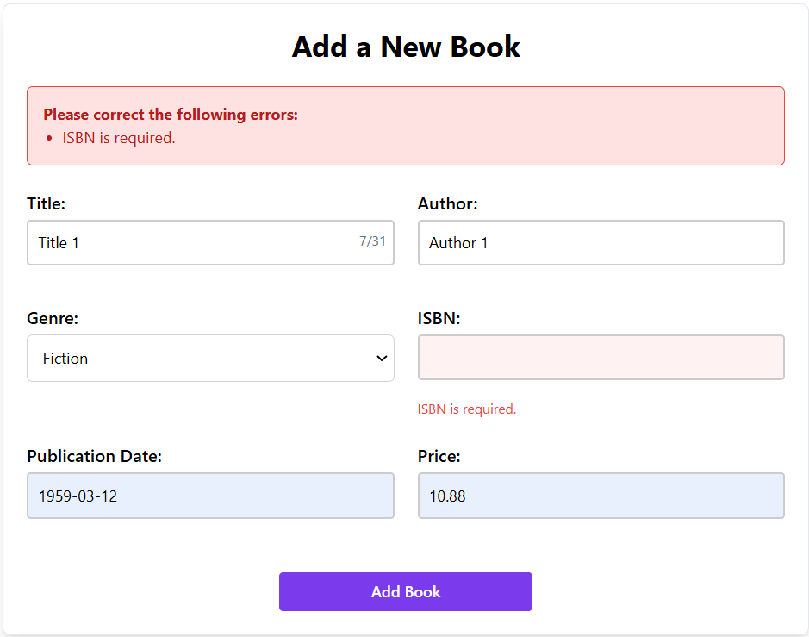 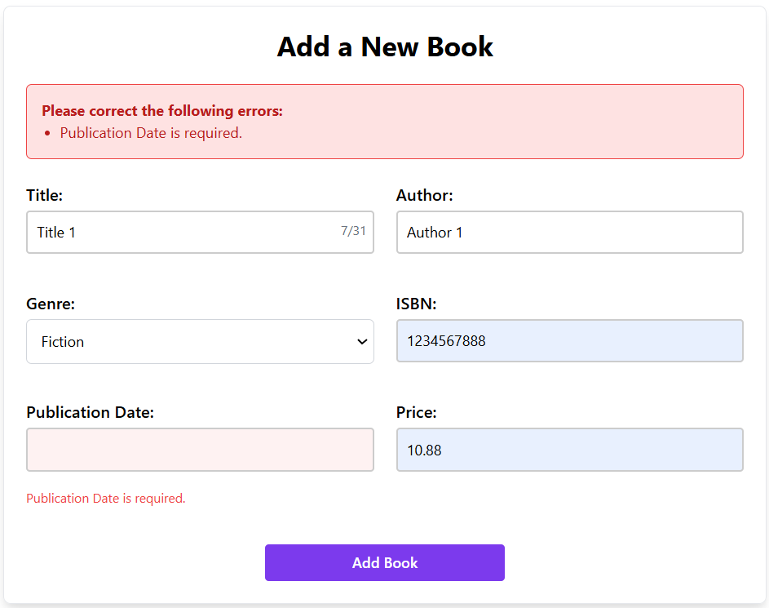

TC_8 Invalid data for Date (allowing text as well)

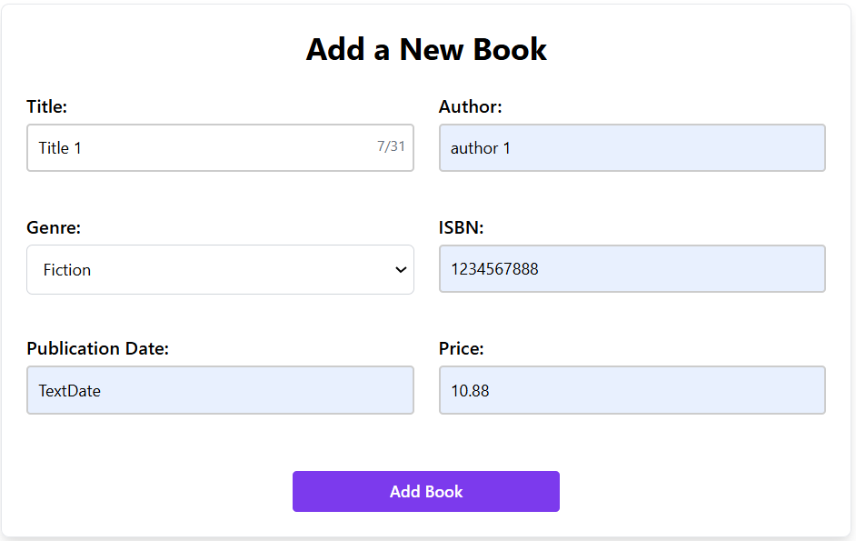

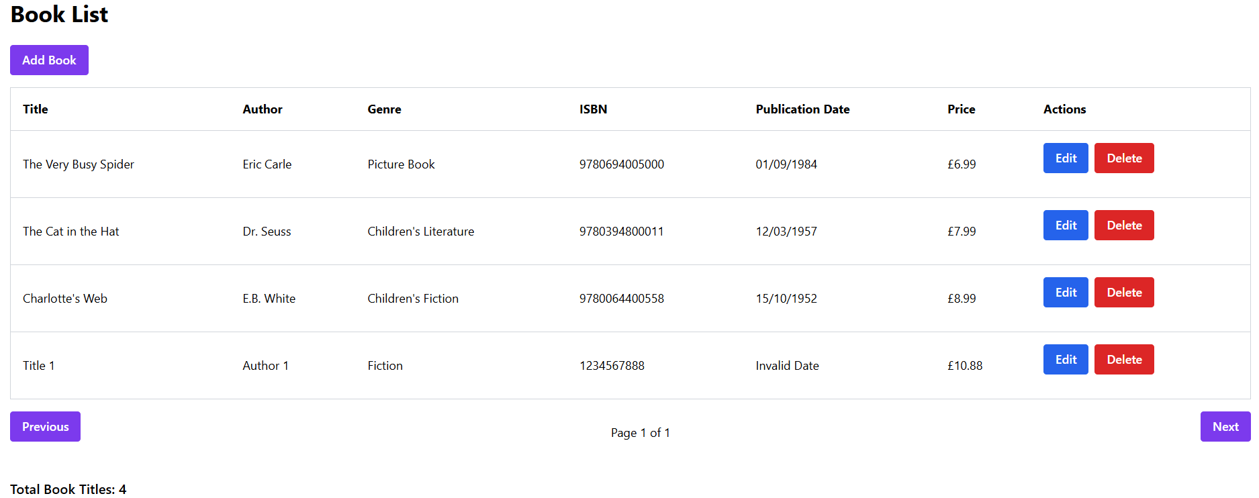

TC_9 Price blank errors TC_11 Edit title blank submission error

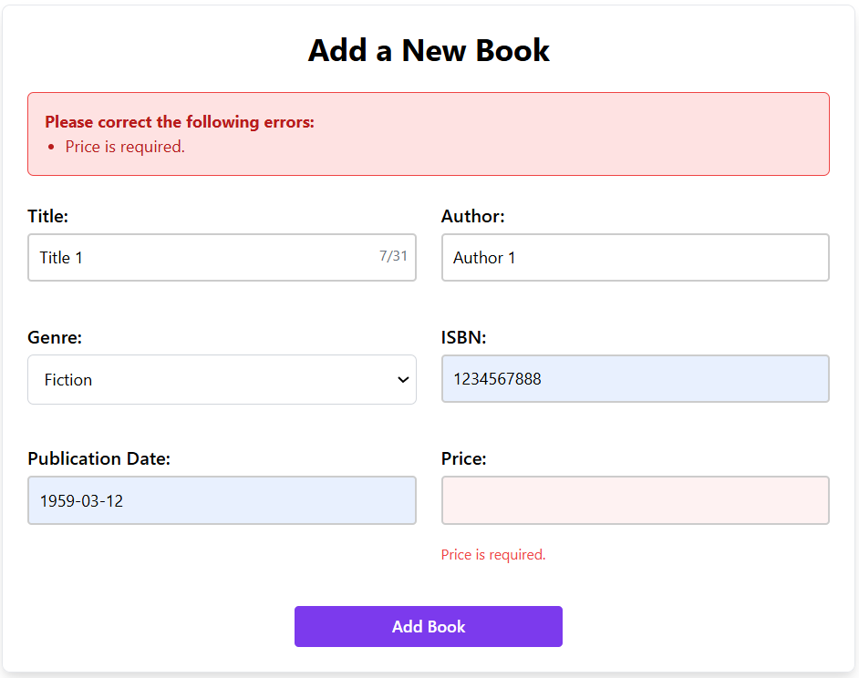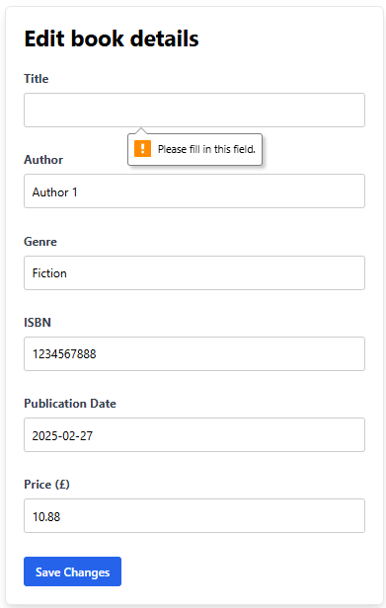

TC_13 Delete All Books Bug (Page 1 of 0) created a bug for this, please refer to the Bugs section

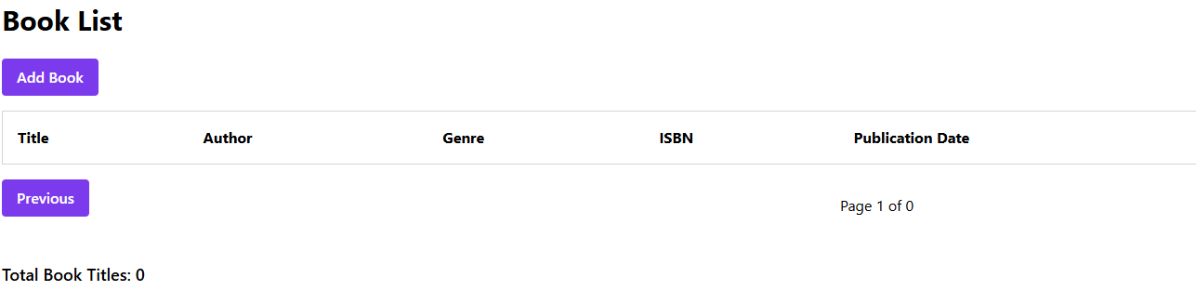

TC_14 Invalid user login error message TC_15 Login blank submission error message

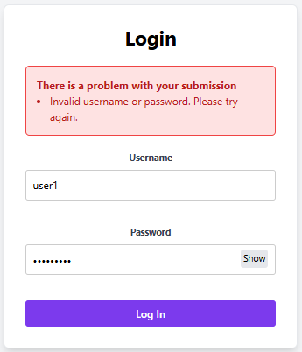 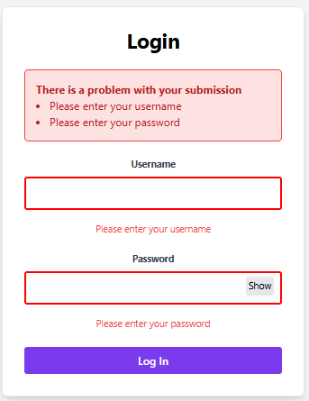

**3. Requirement Gaps**:

1. Search option should be provided to find a book when the book list grows

2. Previous and Next button are present and active even though there is only page to display. Previous button should be disabled/not be displayed when it is displaying first page. Next button should be either disabled/not be displayed when its displaying last page.

3. No message (“no books available to display”) is shown to the user when there are no books present in the system.

4. Book Genre is displayed as free text box in Edit operation; however, it is a dropdown for Add operation. Edit operation should also be let the user choose from dropdown for Genre selection.

5. Once ‘Add Book’ button is clicked on ‘Book List’ page, ‘Add a New Book’ page opens with details. However, there is no button option (either cancel or back) so that user can be taken back to ‘Add Book’ page.

6. ‘Add a New Book’ page ‘Publication Date’ field is given as a free text which is allowing invalid data including text. A calendar date picker should be suggested which is be easy for selecting a date. Also, Date should be validated before submission and display appropriate error message.

7. Confirmation message should be displayed to the user, once Add, Edit, delete book operation is successfully completed

8. Application is allowing duplicates book details addition. This should be restricted.

Snippets for quick reference:

Below snippet is for requirement gaps 1,2,

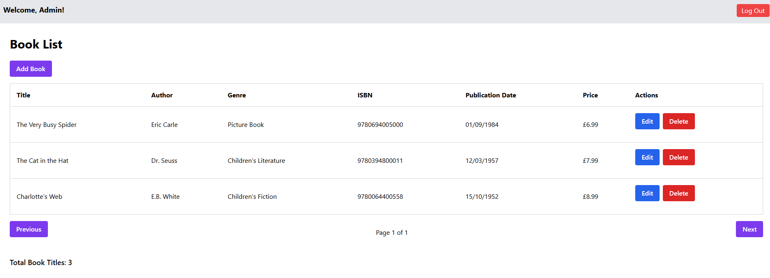

Below snippet is for requirement gaps 4 & 7 (Genre is free text instead of dropdown & no confirmation message)

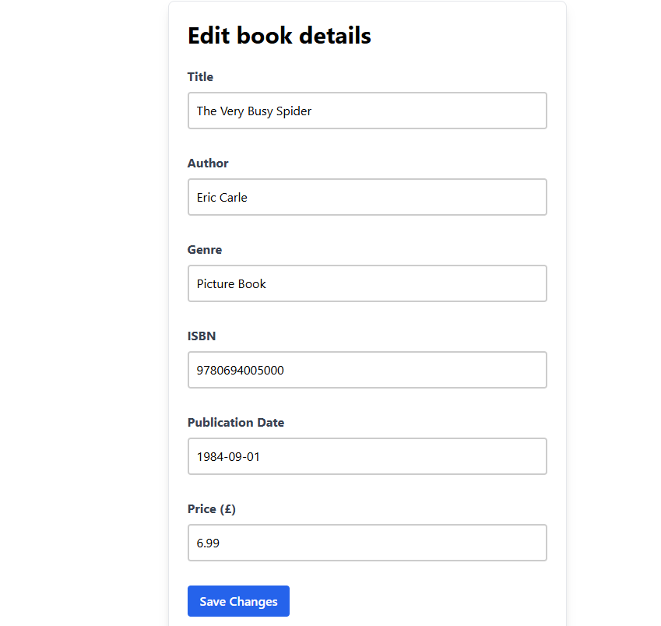

Below snippet is for requirement gaps 5 & 6 & 7

(No cancel button and use calendar date picker for Publication Date & no confirmation message)

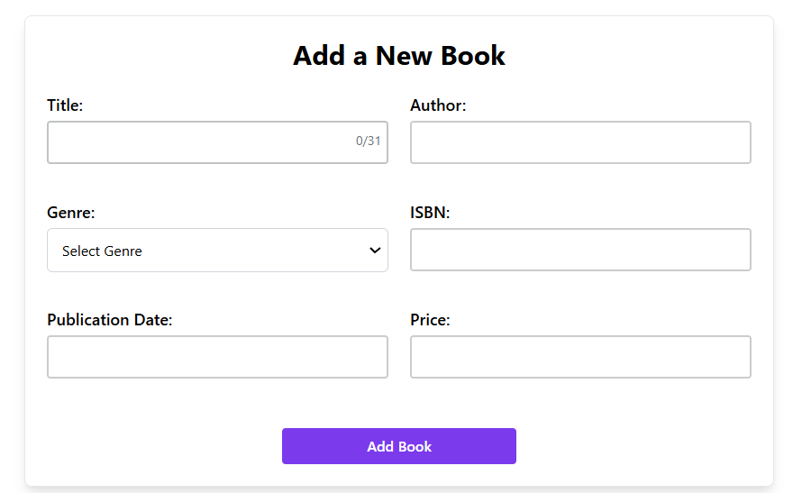

Below snippet is for requirement gaps 8 – Allowing duplicates – but the total count is distinct

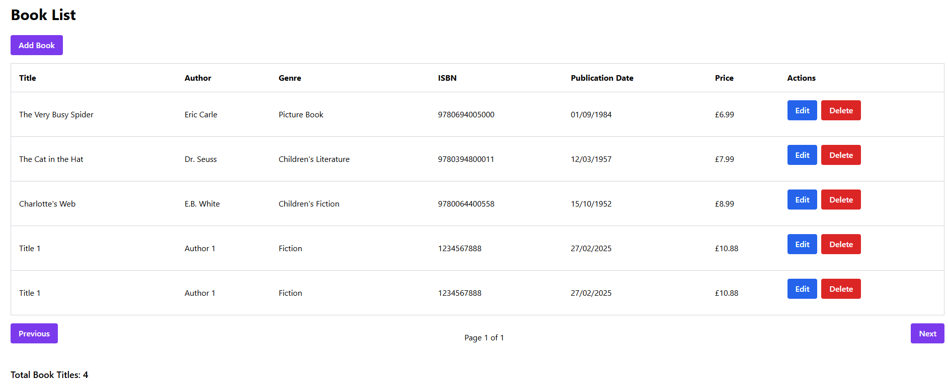

**4. Bugs**:

1. (TC_13) Page 1of 0 where is there are no books to display (delete all books to check this scenario).

2. (TC_8) Add Book page is accepting invalid dates like text and displaying as ‘Invalid Date’ in UI

3. (TC_16) Log Out action is not redirecting to Login Page and its still on Book List Page. 1 of the automated tests is failing as its application Issue (Test Case 9)

Snippet for requirement gap 3 & Bug 1 (no books for display message & page 1 of 0)

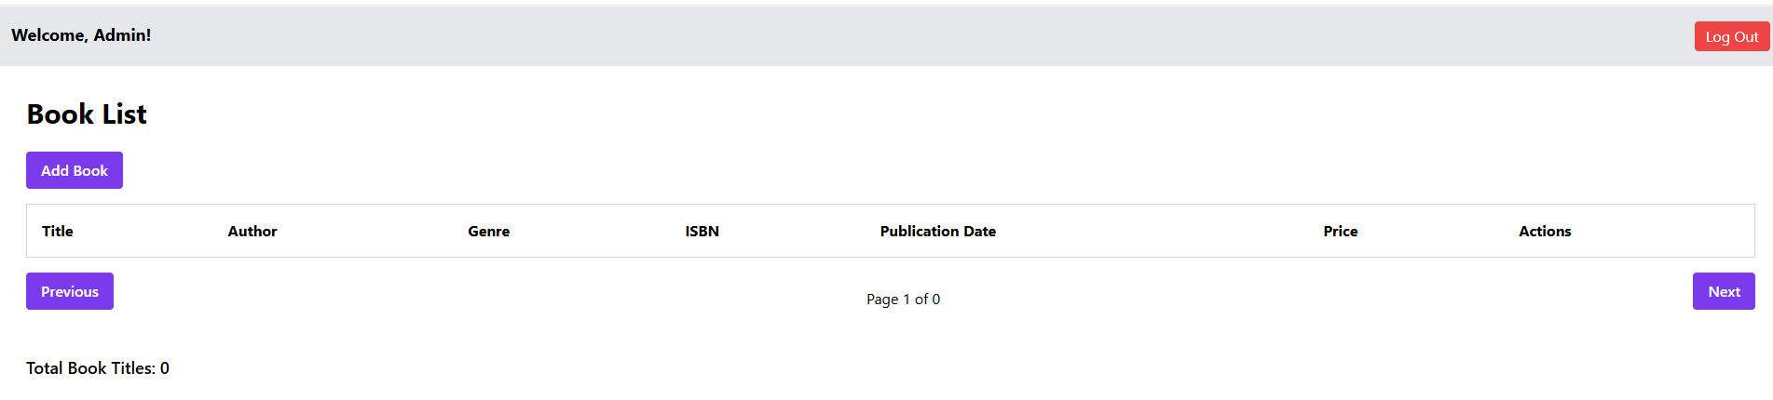

Bug 2 Snippet:

Add Book page is accepting invalid dates like text and displaying it as ‘Invalid Date’ in UI

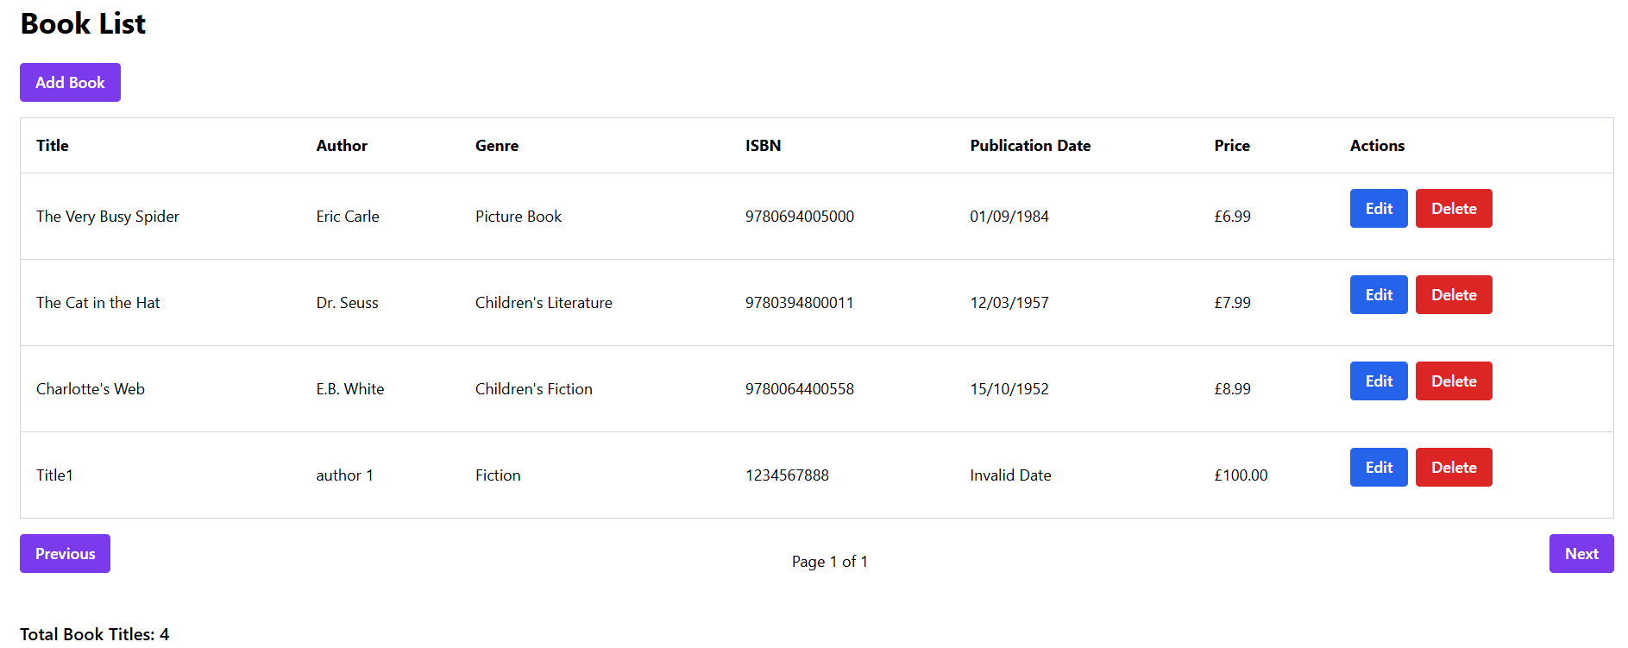

Bug 3 Snippet:

Log Out action is not redirecting to Login Page and it’s still on Book List Page

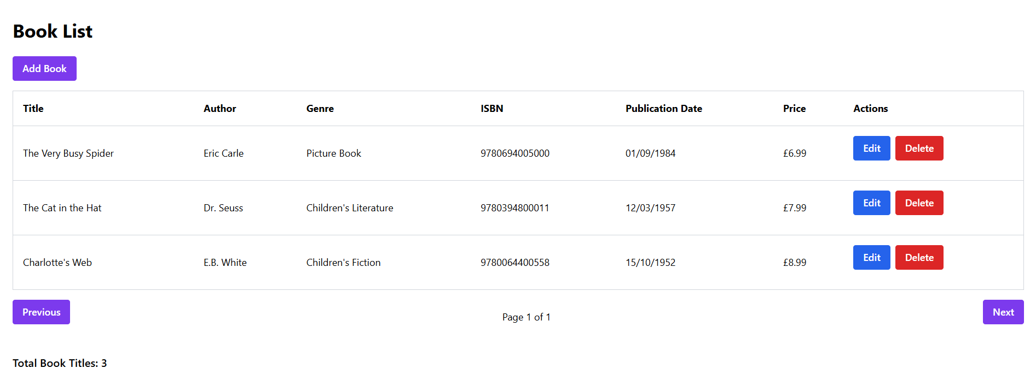

Prepared by: Ravikumar Martha